BASIC MATHEMATICS FORM TTWO

**MARKING SCHEME**

SECTION A

1. Given 391587

Largest number 987531……………………..(05 marks)

Smallest number 13789………………………(05marks)

1. (a) solution

$x^{2}+8x+T={(x+B)}^{2}$

$=\left(x+B\right)\left(x+B\right)$

$x^{2}+8x+T$ $=x^{2}+2xB+B^{2}$ (01mark)

Comparing like terms

$\frac{8x}{x}$ $=\frac{2xB}{x}$

$B=4$ (01mark)

$T=B^{2}$ but $B=4$

T $=4^{2}$

T $=16$ (01mark) (01mark)

∴ $T=16$ and $B=4$ (02marks)

(b) $=$



 $=$

$=$ 01mark



 $=$

$=$ 01mark

n $-1=-4n$

n $+4n=1$

5n $=1$

n $=$

1. 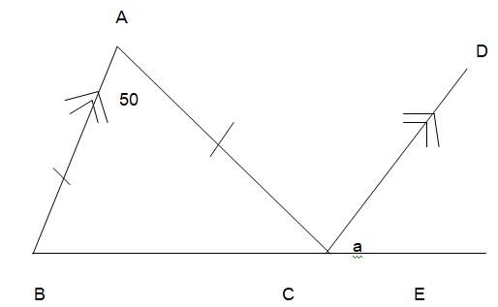

Required to find angle DCE =a

From the figure, Angle ABC $=$ Angle ACB=x Since Triangla ABC is isosceles 2marks

Angle ABC+Angle ACB + AngleBAC =180° 2marks

$x+x+50$ =180 2marks

So, 2 $x$ +50=180

, 2 $x$ =130 1mark

$x$ =65° 1mark

But line AB is parallel to line CD 1mark

So, Angle ABC = Angle DCE =65°

$a$ =65° 1mark

1. From $I=\frac{PRT}{100}$ 2marks

Where P= $400000/=$**,** I= 9600/=, R=12%

Making T the subject of the formula

T= $I×\frac{100}{PR}$

1mark

T= $96000×\frac{100}{400000×12}$ 1mark

Substituting the values T=2 1mark

1. LCM and GCF of 16,24 and 36

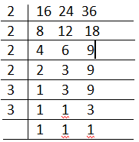

1MARK

GCF =2 $×$ 2

=4 1MARK

LCM = 2 $×$ 2 $×$ 2 $×$ 2 $×$ 3 $×$ 3

=144 1MARK

The product of LCM and GCF = 144 $×$ 4=576 2MARKS

1. (a) Given that (x $+40°) and (2x+5°)$ = 90°

$x+2x+40°+5°$ = 90° 1mark

3x=(90-45)° 1mark

=45° 1mark

So, x=° 1mark

x=15° 1mark



(b) To rationalize the denominator

=() $×$ () 2marks

= =  2marks

= +4 1mark

1. (a) ${6x}^{2}-11x+4$ by spritting the middle term

ac=24

b= $-11$ 1 mark

factors are -3 and -8 1 mark

$${6x}^{2}-3x-8x+4$$

$$3x\left(2x-1\right)-4(2x-1)$$

$\left(3x-4\right)(2x-1)$ 3marks

$${6x}^{2}-11x+4=\left(3x-4\right)(2x-1)$$

(b) $4y-41=-14$……..eq 1

$6x=30-10y$……..eq2

Re-arrange eqns

|  |  |
| --- | --- |
| 6 | $$14x+4y=41$$ |
| 14 | $$6x+10y=30$$ |

1 mark

|  |  |
| --- | --- |
|  | $$84x+24y=246$$ |
| - | $$84x+140y=420$$ |

$\frac{116y}{116}$ = $\frac{174}{116}$ 1mark

$$y=1.5$$

|  |  |
| --- | --- |
| 10 | $$14x+4y=41$$ |
| 4 | $$6x+10y=30$$ |

1 mark

|  |  |
| --- | --- |
|  | $$140x+40y=410$$ |
| - | $$24x+40y=120$$ |

$\frac{116x}{116}$ = $\frac{290}{116}$ 1 mark

X=2.5 1 mark

1. $\frac{\log{b}}{log3}=\frac{log16}{log4}$ 1 mark

= $\frac{{log4}^{2}}{log4}$ 1mark

= $\frac{2log4}{log4}$ 1 mark

$\frac{logb}{log3}=2$ 1 mark

$logb=2log3$ 1mark

∴ $b=9$



$\frac{{29.07×(0.0071)}^{4}}{\sqrt{13.22}}$

|  |  |
| --- | --- |
| Number Ax ${10}^{n}$ | log |
| $$2.907×{10}^{1}$$ | 1.4634 |
| 7.1 $×{10}^{-3}$ | $\overline{3.}$ 8513 |
| Numerator | $\overline{7.}$ 8686 |
| 1.322 $×{10}^{1}$ Denominator |  |
| N-D | $\overline{7.}$ 3080 |

10MARK

02MARKS

$=2.032×{10}^{-7}$ 02MARKS

1. (a)

Given line  with coordinates (2,y) and (5,7) wit slope =

From Slope = $\frac{Δy}{Δx}$ 01mark

= 02marks

=

6=21-3y

Y=

=5 02marks

(b)

Given A(6,4), A(3,2) and k=2

Let (x,y) be the centre of the enlargement

k= but k=2 01mark

k= or 2(x-3) = x-6

2x-6=x-6

X=0

k= 01mark

2(y-2)=y-4

2y-4=y-4

Y=0

So (x,y) = (0,0) 03marks

The centre of the enlargement is (0,0)

1. (a)

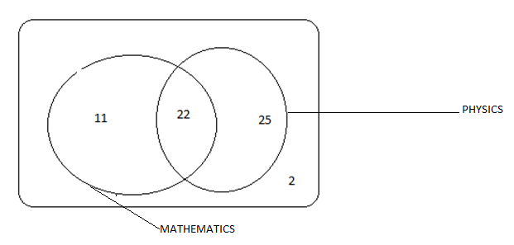 06 MARKS

1. 11 students are taking mathematics only 04marks
2. 35 was scored by many students 03marks
3. 80 was scored by few students 03marks
4. Number of students who passed is 10+5+14+2+6=37

Number of students who failed is 14+18+11=43

The difference = 43students $-$ 37students

=6students 04marks